7. ReactJS-HOL

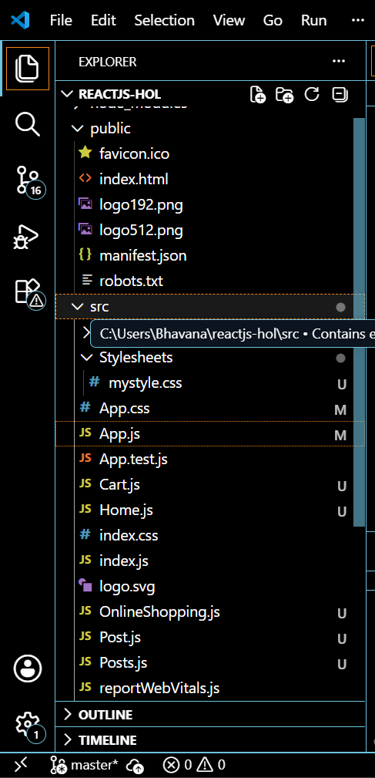

Cart.js
import React, { Component } from 'react';
class Cart extends Component {
render() {
return (
<div style={{ border: '1px solid #ccc', margin: '10px', padding: '10px' }}>
<h3>Item: {this.props.Itemname}</h3>
<p>Price: ₹{this.props.Price}</p>
</div>
);
}
}
Cart.defaultProps = {
Itemname: "Unknown Item",
Price: 0
};

export default Cart;

OnlineShopping.js
import React, { Component } from 'react';
import Cart from './Cart';
class OnlineShopping extends Component {
constructor(props) {
super(props);
this.state = {
items: [
{ id: 1, name: 'Laptop', price: 55000 },
{ id: 2, name: 'Mobile', price: 15000 },
{ id: 3, name: 'Headphones', price: 2000 },
{ id: 4, name: 'Keyboard', price: 1000 },
{ id: 5, name: 'Mouse', price: 800 }
]
};
}
render() {
return (
<div>
<h1>🛒 Online Shopping Cart</h1>
{this.state.items.map(item => (
<Cart key={item.id} Itemname={item.name} Price={item.price} />
))}
</div>
);
}
}
export default OnlineShopping;

App.js
import React from 'react';
import OnlineShopping from './OnlineShopping';
function App() {
return (
<div className="App">
<OnlineShopping />
</div>
);
}
export default App;

OUTPUT:

